**Create the table customer with two column families:**

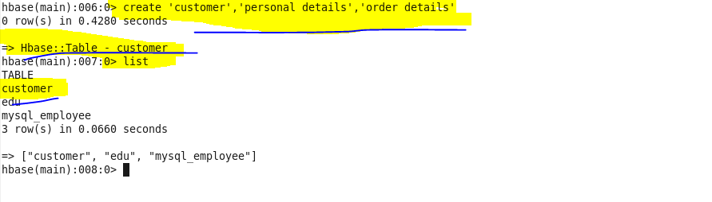

**PERSONAL DETAILS:**

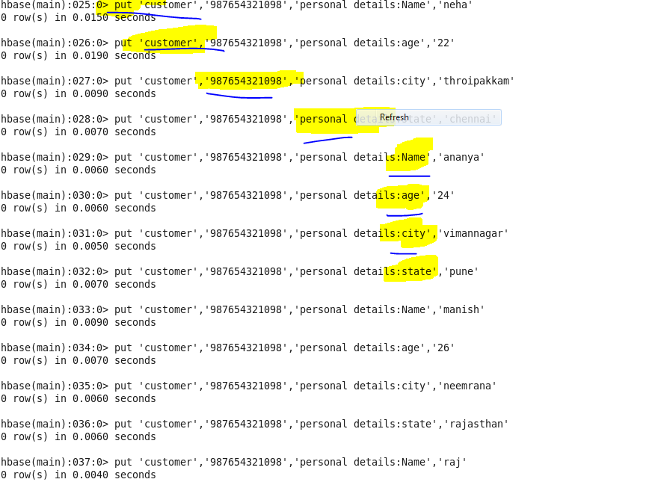

**ORDER DETAILS:**

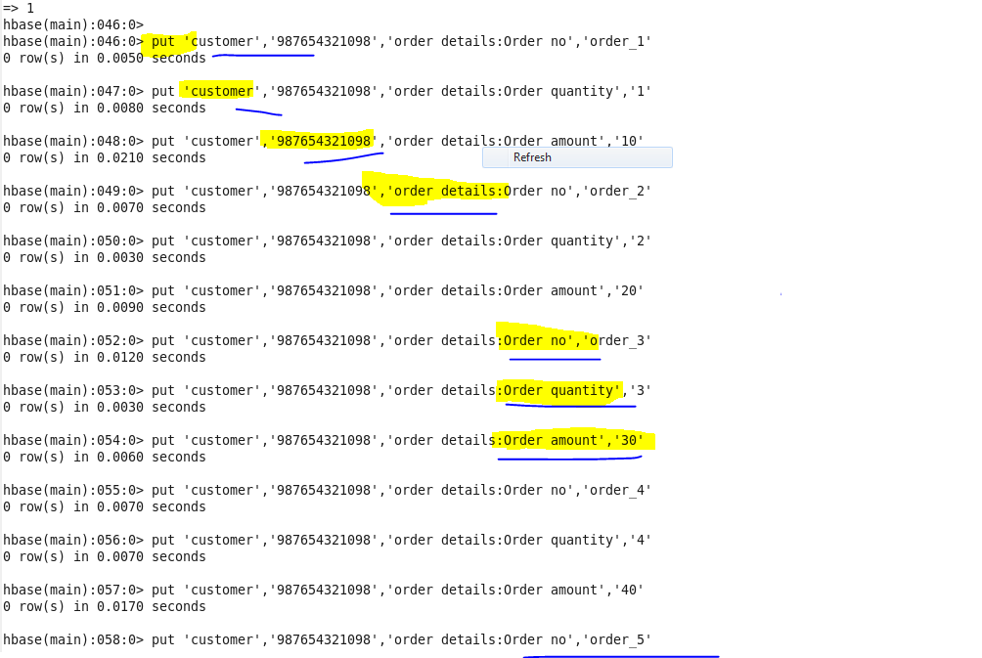

**OUTPUT:**

